**East West University**

**Project Report**

Design a full-fledged network for an organization with multiple subnets.

**Submitted By:**

Gazi Fayaz Ahmed

ID: 2020-1-60-099

Fall 2022

Course: CSE405

Section: 01

**Submitted To:**

Dr. Anisur Rahman

Associate Professor

Department of Computer Science and Engineering

East West University

Submission date: 15/01/2023

**Objective:**

The main objective was to design a complete model of a complex network for University of Scholars and its structure and facilities.

On top of that, a webpage for University of Scholars was to be made and it would be located through the address <http://www.sholars.edu.bd>[.](http://www.apollointernational.edu/) Each Campus was also given a wireless access point to access the network. All the 7 campuses of the university were encompassed in the complex network along with sub-nets inside each campus.

**Implementation Details:**

The network design was implemented in Cisco Packet Tracer. To encompass all the 7 different campuses as well as connecting it to a separate Server Room, a octagonal network of routers was used. Three diagonal paths of the octagon were also connected to provide alternate paths in case any of the routers go down. A wireless Access Point was also provided in each campus through which other devices can connect to the network wirelessly.

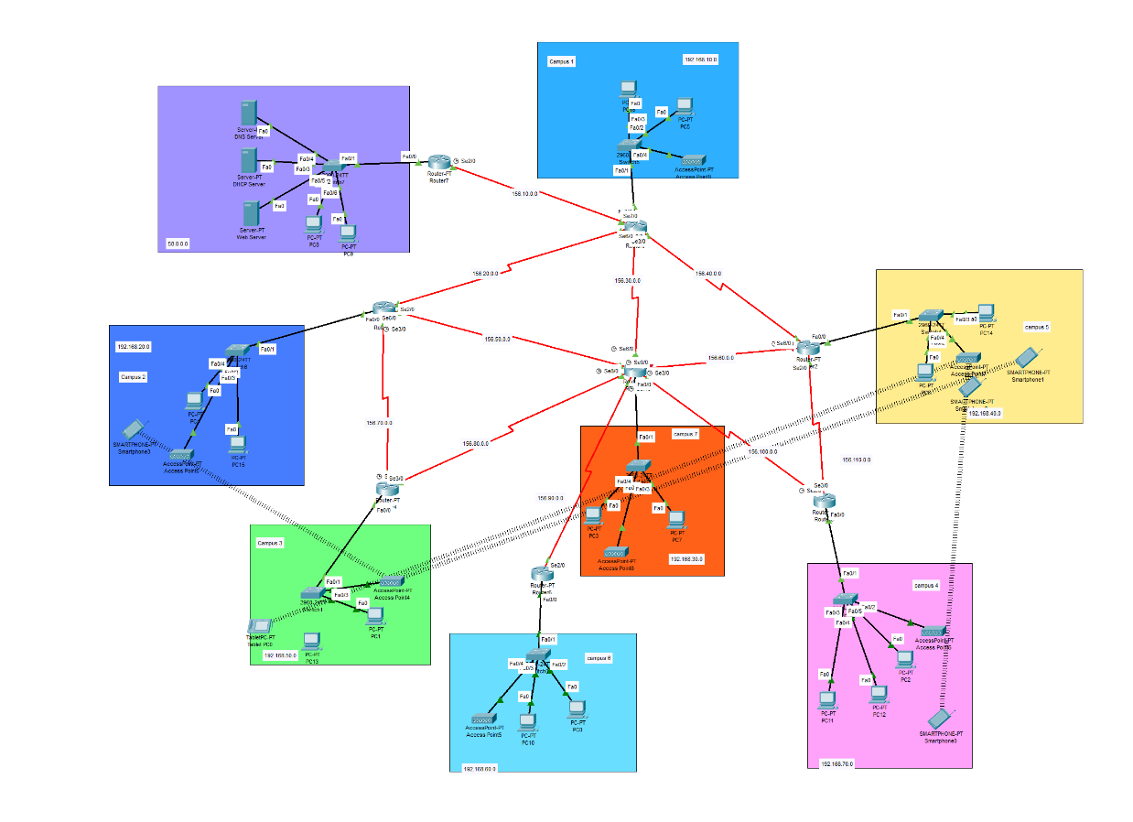

The Network elements used in the project were:

1. Connectors (Straight Through Cable and Serial DCE)
2. Routers
3. Switches
4. Servers
5. PCs
6. Wireless Access points
7. Smartphone
8. Smart Tablet

There were 3 servers that were used. Those were DHCP, DNS and Web Server. All these servers were kept in a Server Room, separate from all the other Campus networks.

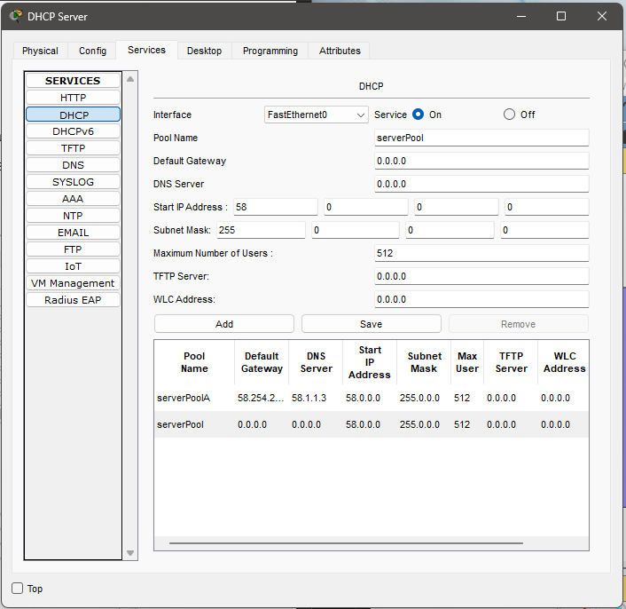

The DHCP server was used to dynamically provide IP addresses to all the hosts present in the 7 campuses.

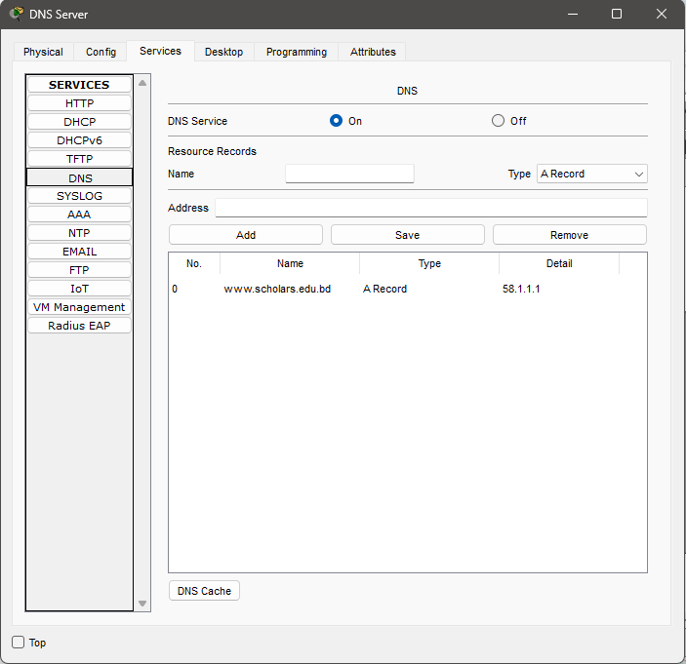

The DNS server was used so that all the hosts can access the webpage in the Web Server through the required web address instead of the IP address of the Web Server.

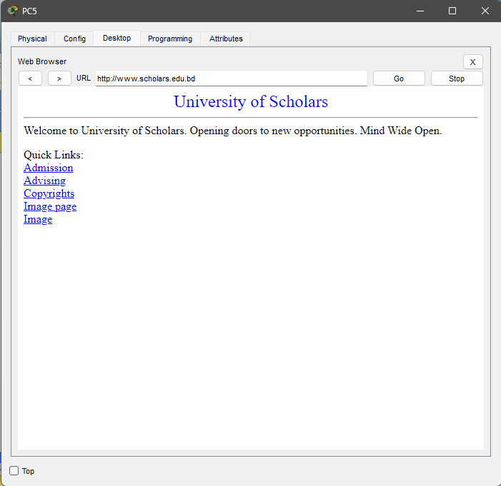

The Web Server was used to provide the webpage of University of Scholars which can be accessed through any of the hosts in any network. The webpage had the required functionalities to display information about Admissions, Advising, Results, Library etc.

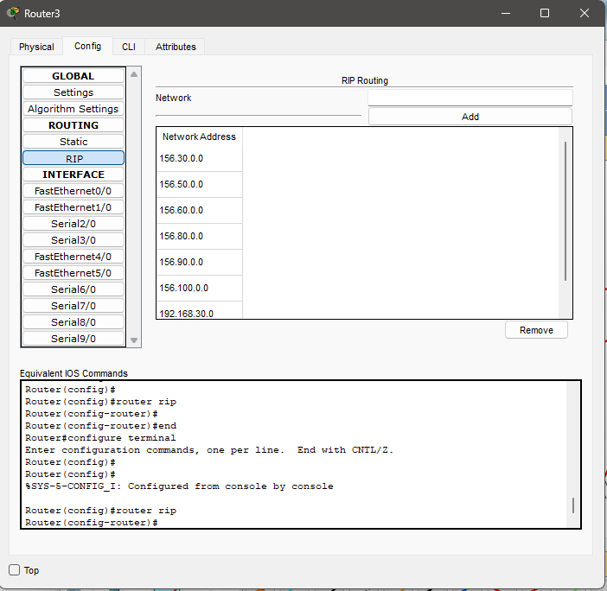

We used static routing algorithm to establish connection between the routers.

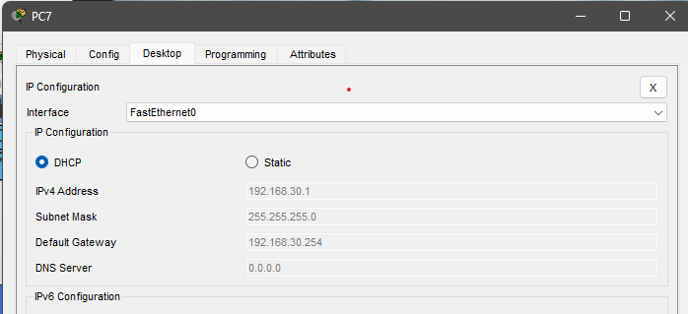

In each of the campuses, the host PCs received their IP addresses dynamically through the single

DHCP server. With this arrangement it is also possible to add new hosts in the network without the hassle of manually allocating IP addresses. The hosts also received information about the DNS server through the DHCP.

**Special Requirements:**

As per the special requirements for creating this network,

* The servers were kept in a separate network in the form of a server room.
* Only a single DHCP server was used to dynamically provide IP address to hosts belonging to all the different networks.
* Network addresses were selected from 3 classes, Class A, Class B and Class C.

**Limitations:**

Due to lack of knowledge of advanced networking strategies and routing algorithms, we used static routing algorithm which might not work if one router in down.

**Conclusion:**

Overall, it can be concluded that the requirements for the complex network of University of Scholars were mostly met. The network design made was functional and it can provide an effective means of communication between the different university campuses. Various extra measures were taken to make the network more reliable and robust. Efficient networking techniques were learnt during the completion of this project and it undoubtedly enhanced my knowledge about networking.